**Azure Coding Challenge - 3**

**Name:** V Venkata Sri Prasad

**Batch:** Data Engineering

**Date:** 21/02/2024

Email : venkatvanniya2002@gmail.com

Question:

Execute & explain, Azure datafactory and its copy activity.

Azure Data Factory (ADF) is a cloud-based data integration service that allows you to create, schedule, and orchestrate data workflows. It enables you to collect data from various sources, transform it, and then load it into data stores such as databases, data lakes, or data warehouses

It works in 3 steps

* Connect and collect
* Transform and enrich
* Publish

COPY ACTIVITY: Copy Activity in Azure Data Factory copies data from a source data store to a sink data store.

One common task in Azure Data Factory is copying data from one location to another using pipelines. Here's a brief overview of how this process works:

**Define the Source and Destination:**

In ADF, you start by defining your data sources and destinations.

Creating storage accounts :

Source storage account

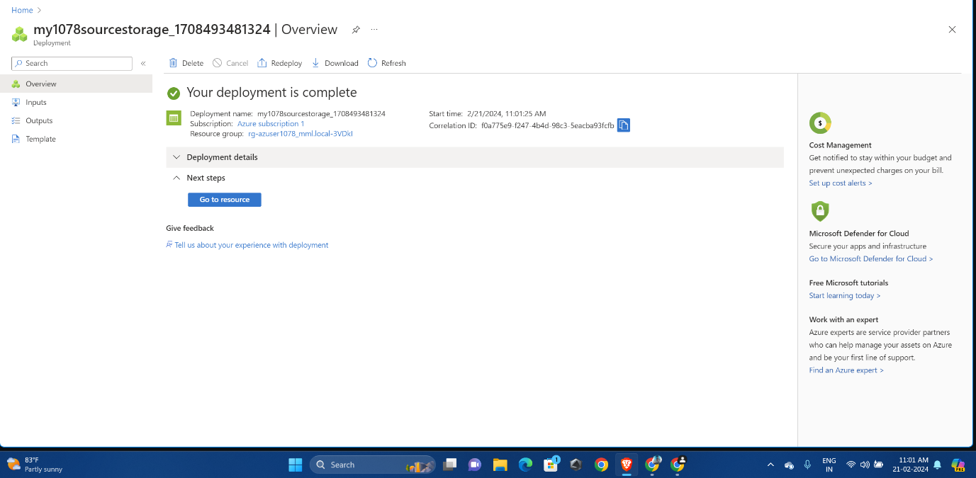

Uploading a JSON file in source storage account:

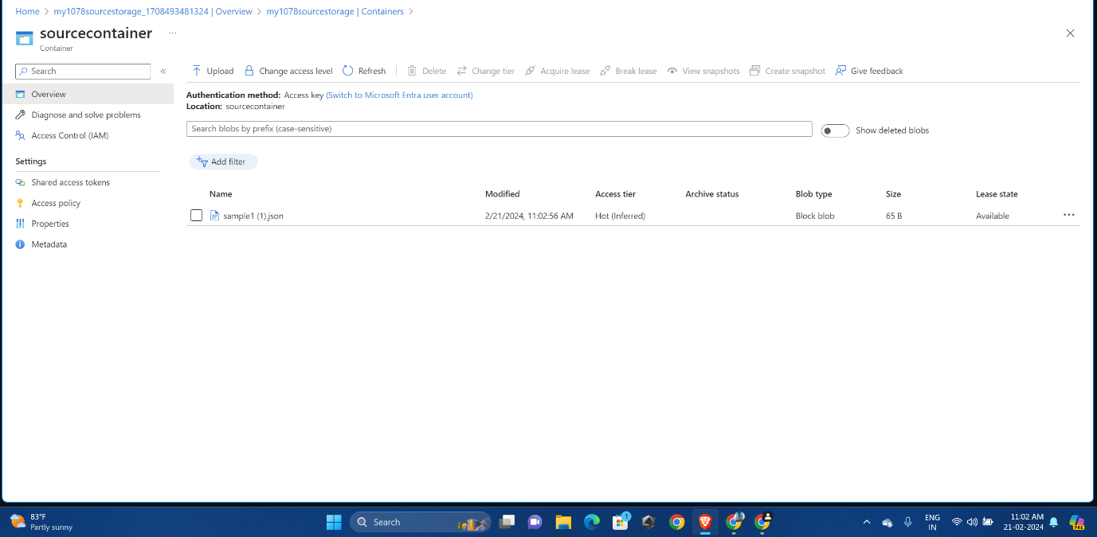

Destination storage account

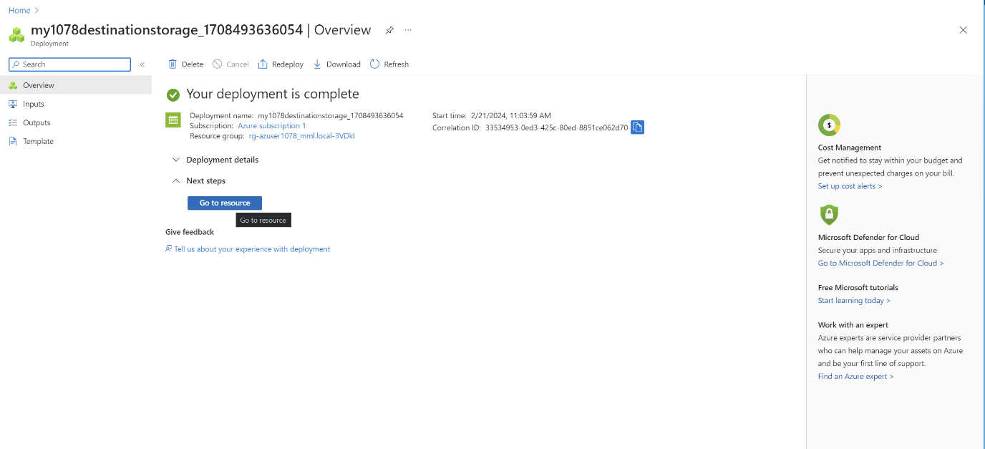

Now Create Data Factory account:

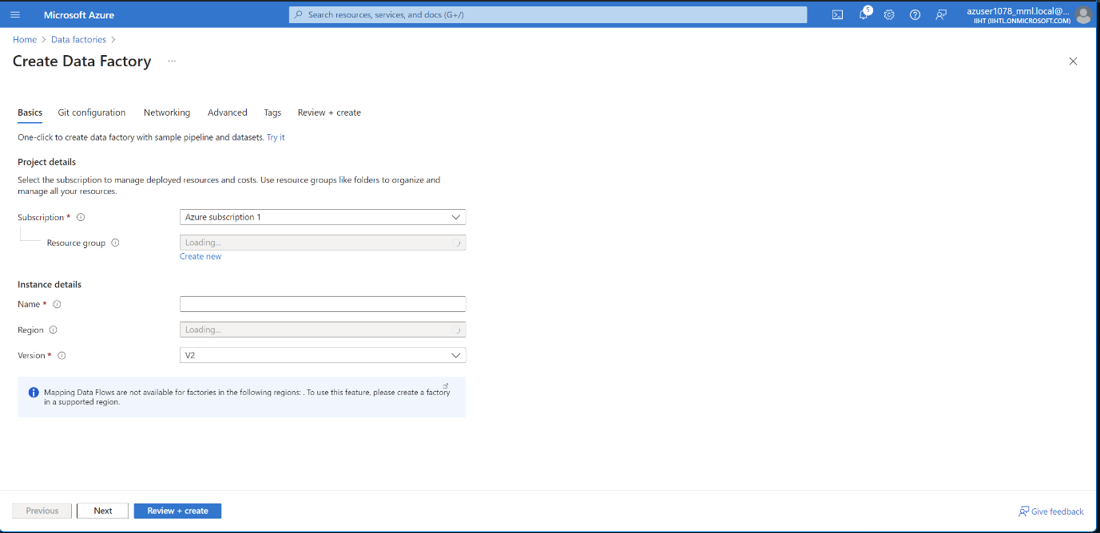

Click on go to resource:

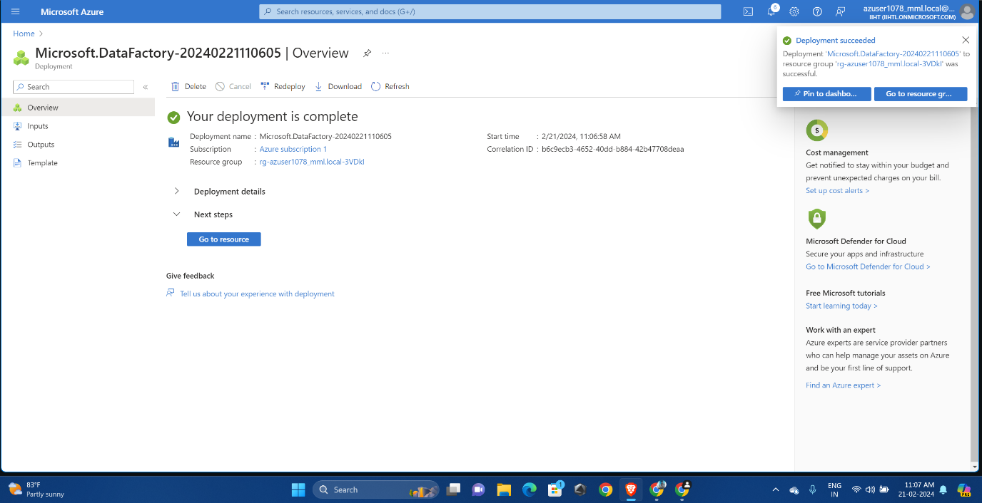

Click on launch studio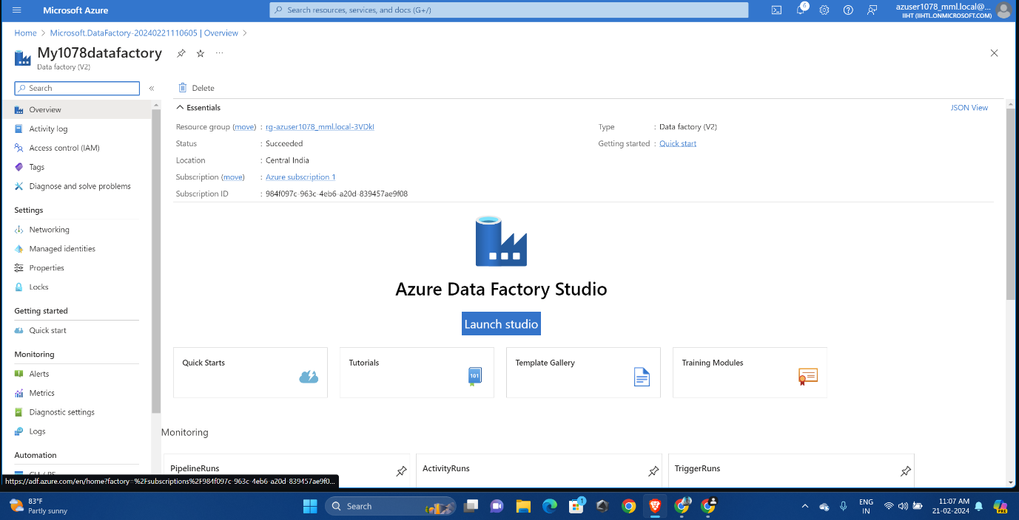

Open Ingest:

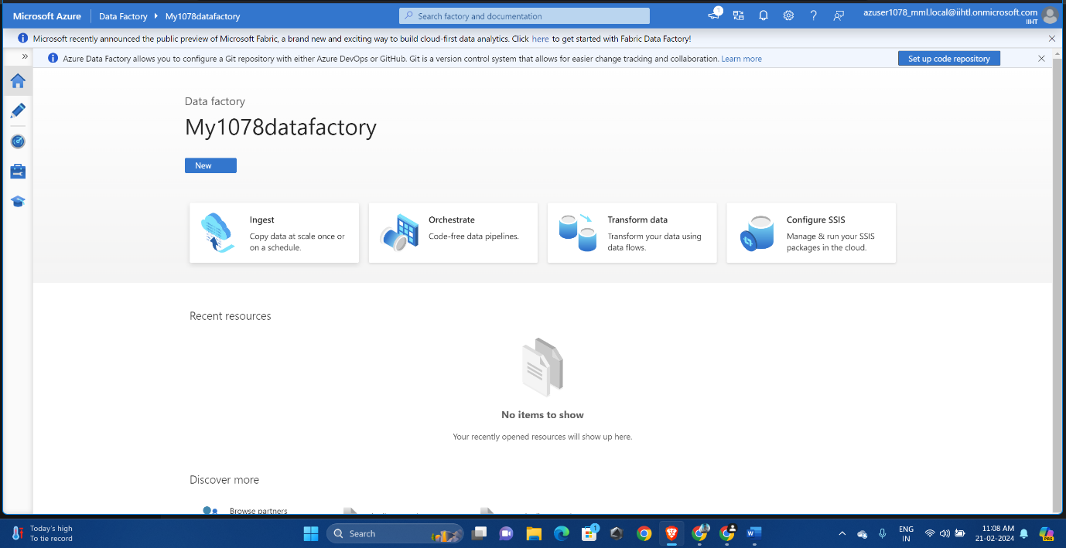

Select Built-in copy task and click on run once now

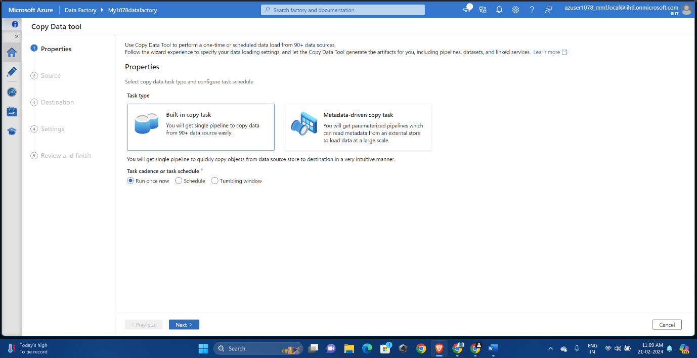

Select the source type and provide azure blob storage ( you can provide ADLS also):

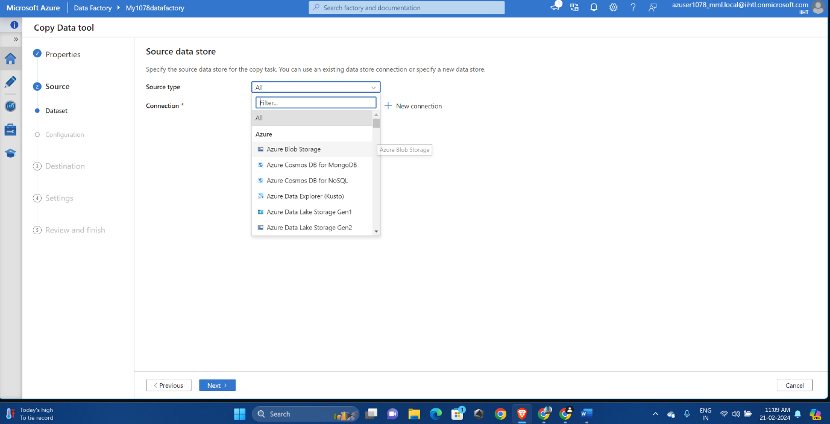

Provide the account key as authentication type and click on storage account name, provide path

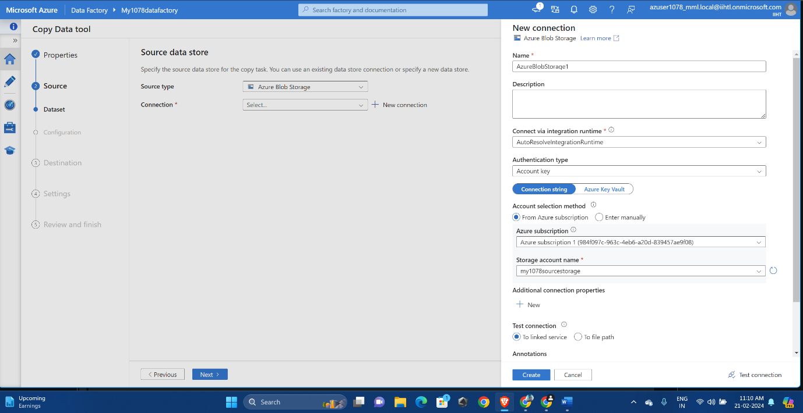

Select file or folder which you need to share.

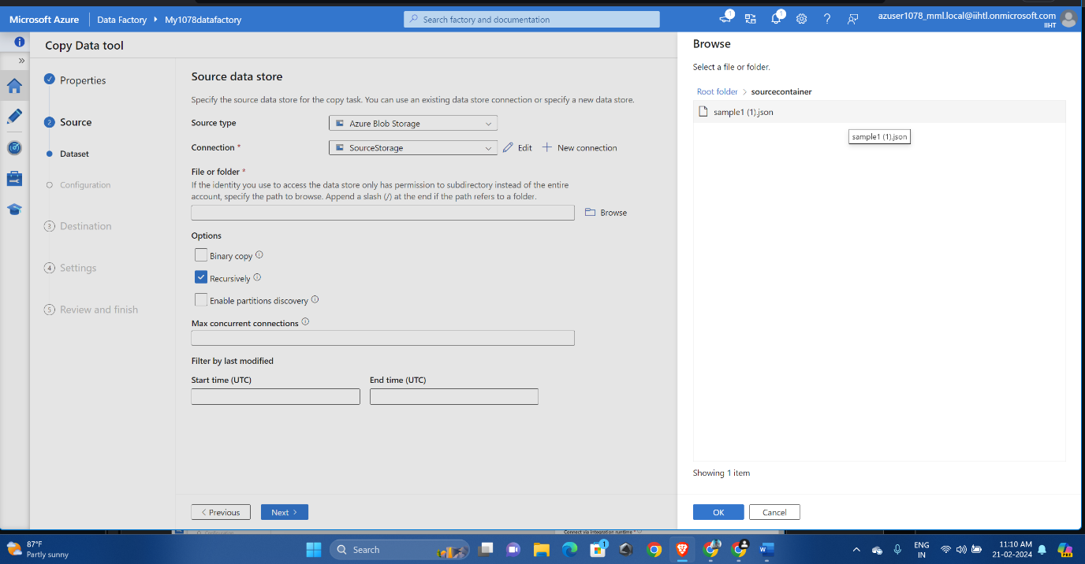

Provide the proper file type and click next

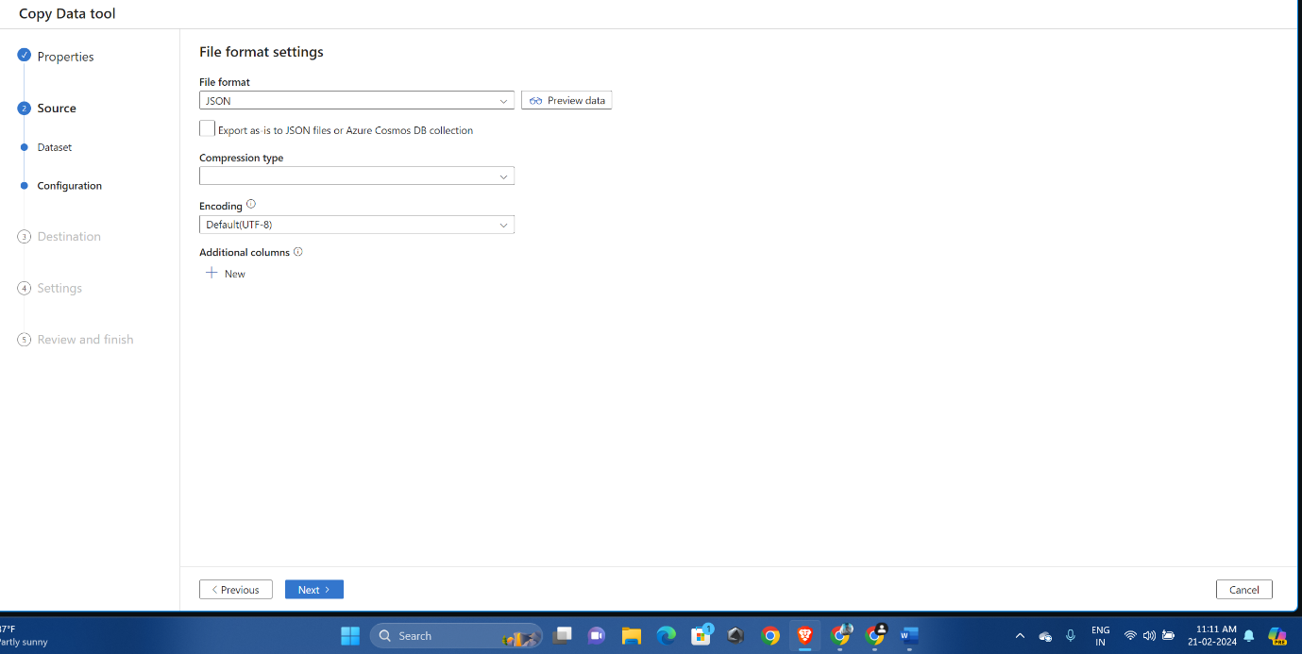

Now same as source storage , provide the destination storage file

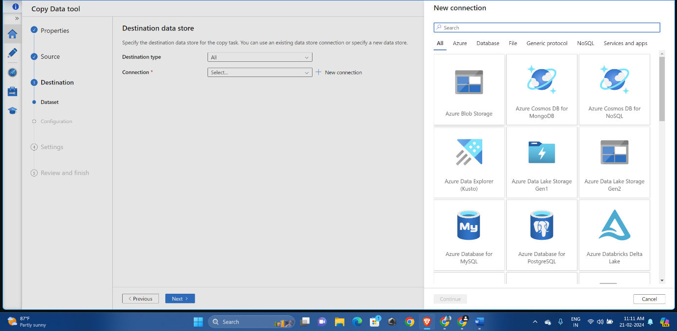

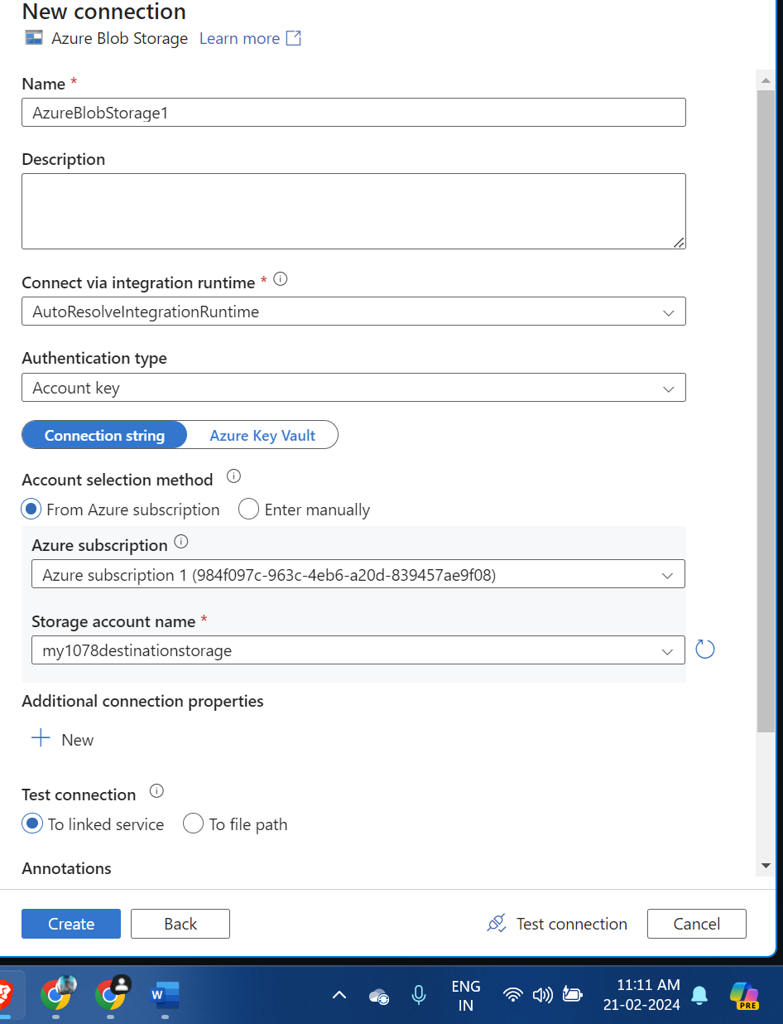

Provide the copy activity task name and click next:

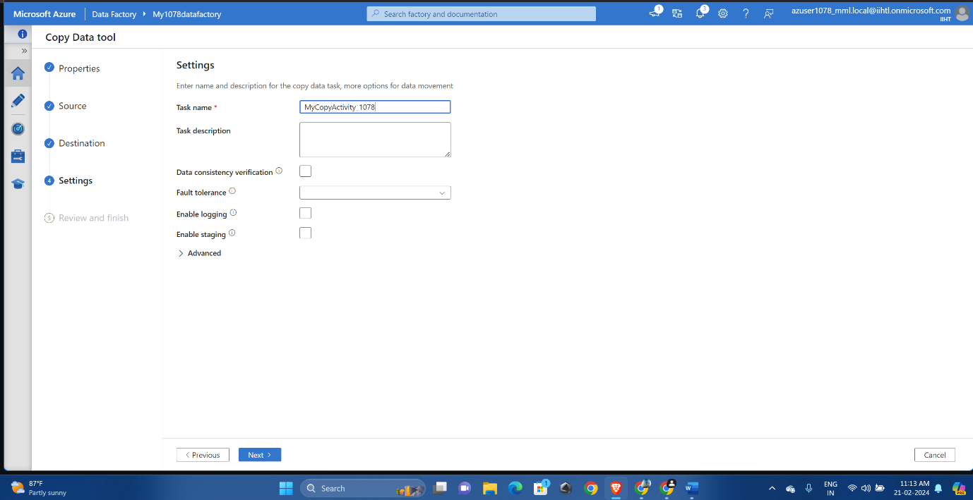

Click on deploy and after the deployment is successful then click on Finish

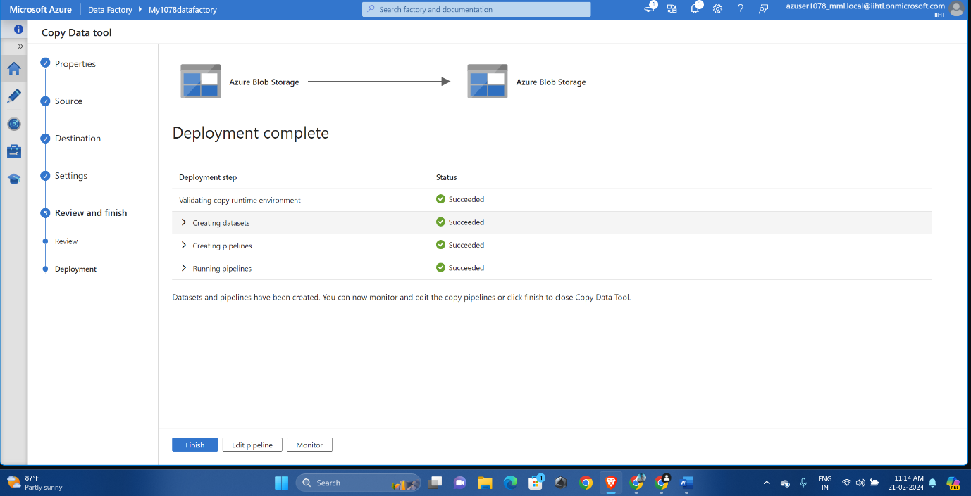

Go to the edit mode and click on pipelines ,start validating and debugging the activity

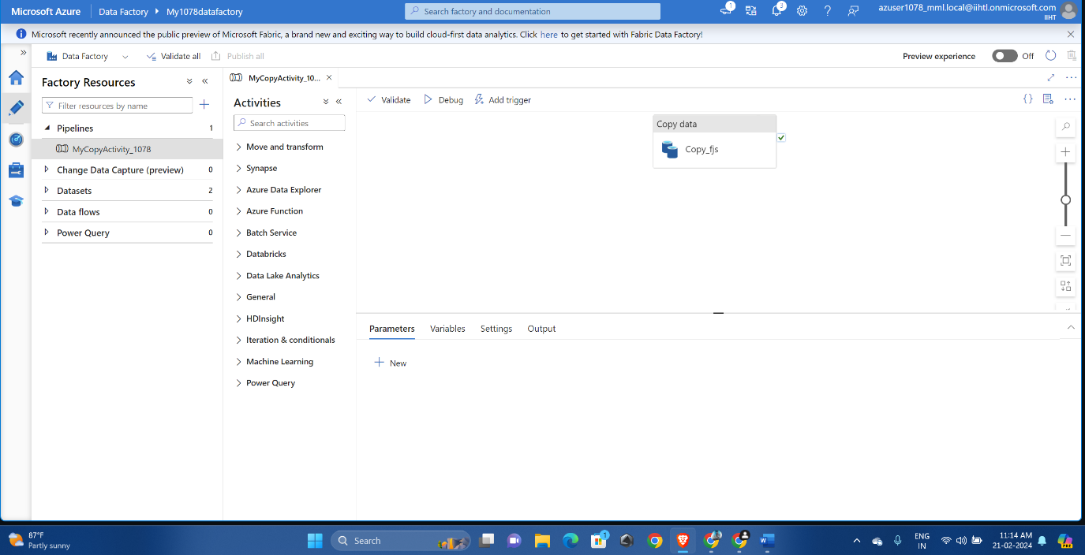

So, debugging is succeeded and we got errors.

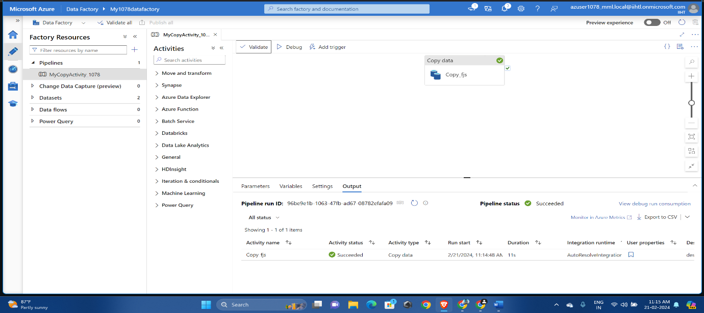

So we can see here the file is present in the destination container

